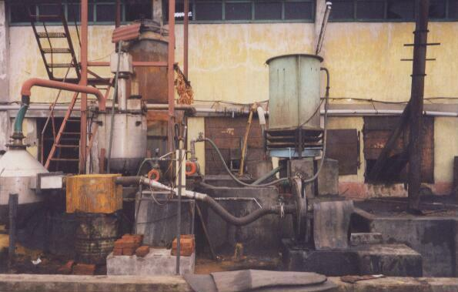

One of the first gasifier installation of our company. The plant is of 250,000 kcal/hr capacity. This plant as supplied by ‘ANKUR’.

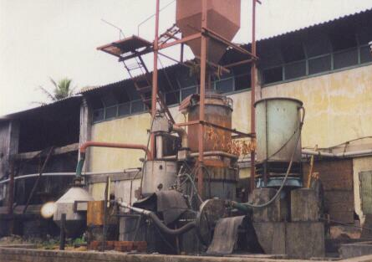

Another view of the gasifier.
Notice the forced draft cooling tower.

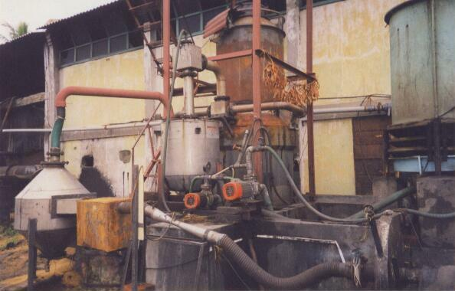

Close-up view. The plant is still operational after 7 years of installation. Most of flexible pipelines have been since replaced. The force draft cooling tower has also been replaced.
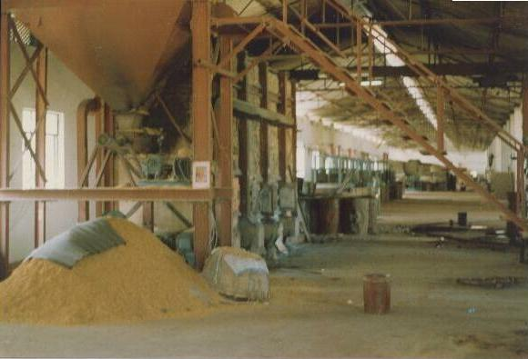

Fuel Handling System for conveying paddy husk into the gasifier.

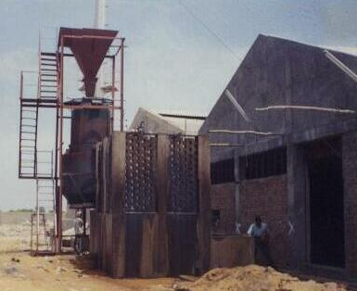

Biomass Gasifier along with the structure. The checkered brick work is a natural draft cooling tower to provide cooling water for scrubbing. Gasifier capacity 625,000 kcal/hr.

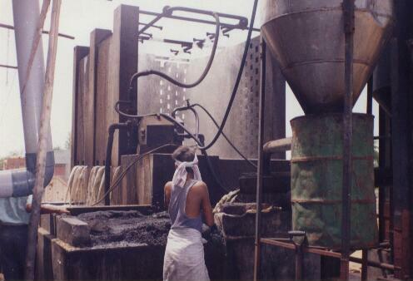

Char removal. In this project char is removed manually. The water in the system needs to be changed every 200 hours of operation. Notice the dirty black colour of char in the plant area.

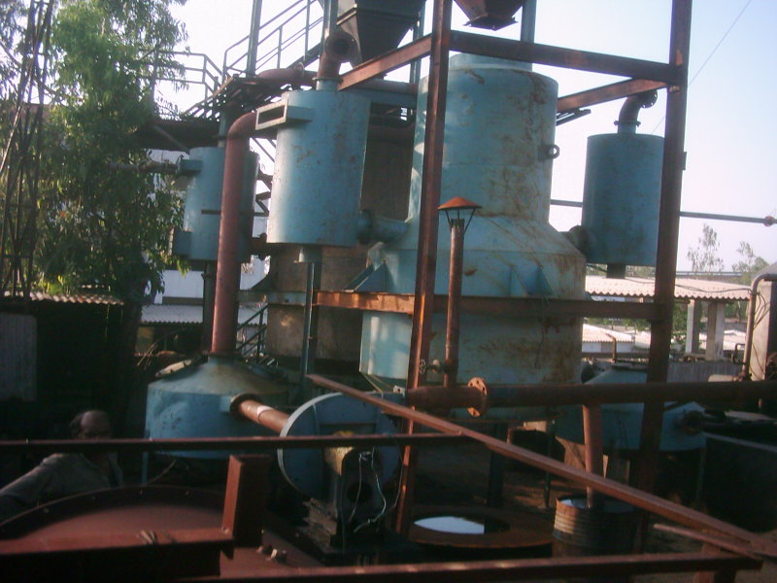

This plant supplies gas as part fuel to a 60 tons / day reheating furnace of a steel re-rolling mill.

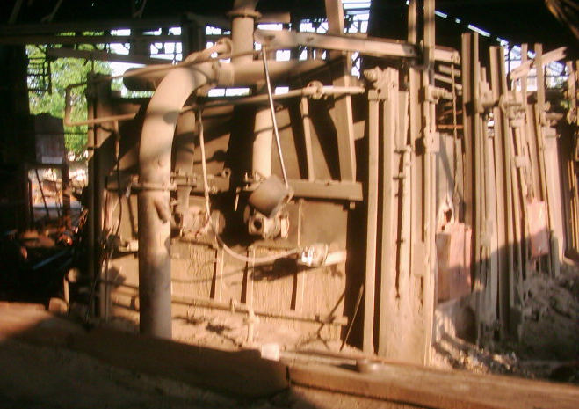

A view of the re-heating furnace along with gas burners.

The gasifier plant supplies 130 litres per hour equivalent of gas for the furnace. This plant operates for 16 hours/day 26 days a month.
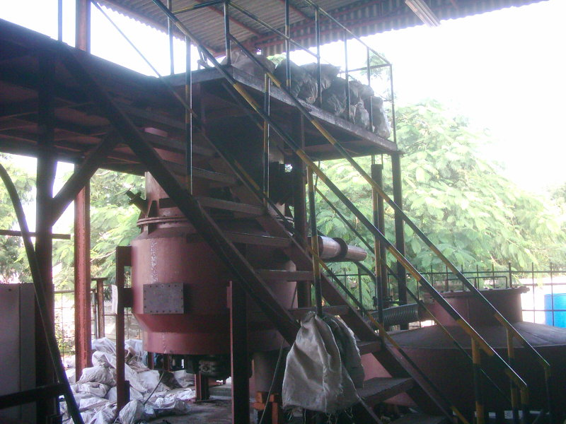
Single gasifier unit of 5,00,000 kcal/hr. This is one among the five units installed to replace LDO as fuel for drying. The plant has 17 dryers and these gasifiers now replace LDO from the plant.

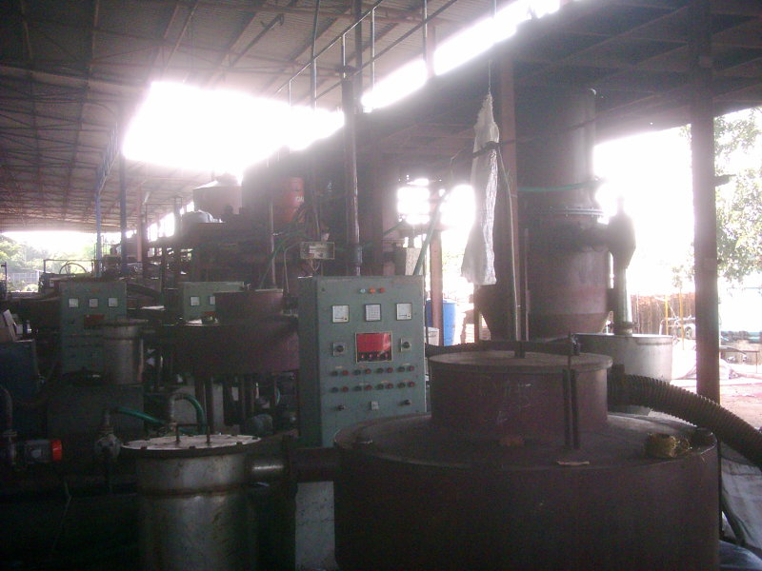

A view of all the gasifiers installed in the plant.

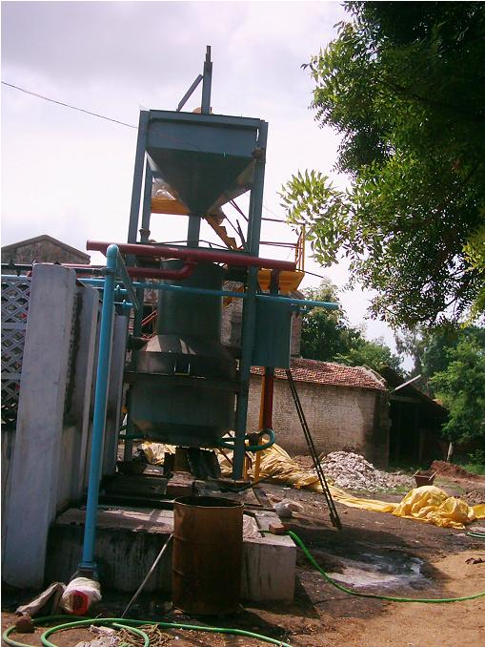
This gasifier plant supplies gas to fuel a down draft kiln at clay pipe manufacturing unit. The temperature is 1100 Deg C. Coal was being used as fuel in the past.

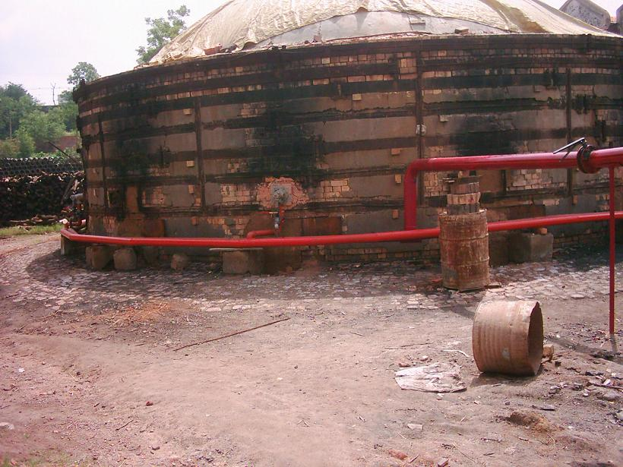

A View of the DD Kiln

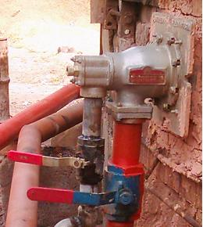

A view of the burner.

