Summary of Biomass Power Generation in India
2005.07.21
Hitofumi Abe
abejin@plants.uwa.edu.au

This report was prepared for Japan International Cooperation Agency (JICA) project ‘The Master Plan Study on Rural Electrification by Renewable Energy in The Kingdom of Cambodia’ as a part of case studies of other Asian countries.

- Overall Summary

The government of India strongly encourages the utilization of biomass energy. All renewable energy matter is under jurisdiction of Ministry of Non-Conventional Energy Source (MNES). MNES estimated the biomass power potential in the entire country as 19,500 MW. To obtain the maximum utilization of such high potential energy source, MNES has been conducting various researches such as technologies, resource assessment and system modelling on biomass energy sector. As the results, India now becomes one of the leading countries of biomass energy utilization.
The commissioned biomass power capacity reached 290 MW (52 projects) and the commissioned co-generation capacity installed mainly at sugar mills reached 437 MW (57 projects) by the end of year 2004 (Table 1). In addition to above, a total capacity of 55 MW (1817 projects) of biomass gasifier system has been installed by June 30th, 2003. Biomass gasification is the most appropriate technology for Cambodia’s rural electrification and I report details and case studies of biomass gasification in India.

Table 1. Biomass power installations in India.
 | Biomass Power¹ |  | Co-Generation¹ |  | Gasifier²
 | MW | No. | MW | No. | MW | No.
Commissioned | 290 | 52 | 437 | 57 | 55 | 1817
Under Implementation | 284 | 41 | 323 | 35 | n.a. | n.a.
¹ by 31-12-2004, ² by 30-06-2003, n.a. not available
(Source: MNES)

- Biomass Gasification Electricity Application

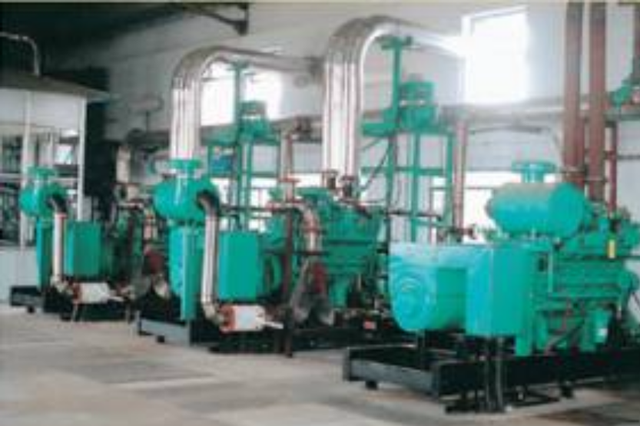
Biomass gasification electricity generation has been installed for both mini-grid rural electrification and supply for main grid. There is 1 MW capacity of 100% producer gas based grid connected power generation was commissioned in December 2004 (Figure 1). This is operated by Arashi Hi-Tech Bio-Power Pvt. Ltd in Coimbatore, Tamil Nadu State as independent power producer (IPP). They started the operation in 2002 using duel fuel engines but engines are replaced with 4 x 250 kW Cummins producer gas engines and an additional gasifier. Currently Juliflora (Prosopis juliflora) wood is used as the feedstock and the system has already been operated over 4,000 hours. Juliflora is very common legume woody weed in the state. There are many various size of biomass gasifier rural electrification scheme commissioned. Gosaba Island project (refer the case study) is the oldest relatively large scale (500 kW) scheme and has been operating since 1997. The 4 x 250 kW (1 MW) installation in Khtrichera, Tripura State would be the largest biomass gasifier rural electrification project.
Figure 1. 100% producer gas engines at 1 MW power station in Tamil Nadu State (Source: http://mnes.nic.in/annualreport/2004-2005_English/ch7_pg4.htm)

Subsidies for rural electrification
Subsidy for biomass gasification rural electrification varies depending on the plant capacity, ownership and location. In case of rural electrification owned by community, up to 90 % of total initial cost would be supported by national government and the rest can be met by community or rural government.

- Case Study

3.1 Gosaba Island Rural Electrification

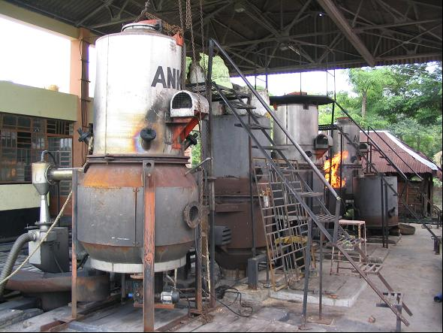
About three million people inhabit the Delta Region of Sunderbans, West Bengal State. Two million of them do not have access to electricity. It is not economically feasible to extend grids to many islands wide spreaded in the Delta Region. The 500 kW (5 x 100 kW) biomass gasifier duel fuel power generation system (70% biomass + 30% diesel) was installed at Gosaba Island, Sunderbans in June, 1997 (Figure 2). Gosaba Island located about 80 km south west of Kolkata. It takes 1.5 hours by boat from the nearest port of mainland. There were only 16 customers when the operation started because people did not believe the system really works. But customer increased very quickly and currently 1150 HH are connected. The plant is currently operating 15 hours a day (10:00 am to 1:00 am next day). The island developed dramatically since the power station installed. There are so many commercial stores and more than 10 hotels, and people from near by islands come to Gosaba for shopping. There is a bank (State of India Bank) opened and support economical activities. Telecommunication system is available. Internet is available and there is a PC training centre. The hospital can conduct basic operations. The electricity is also used for public purposes such as street lights, school lighting, drinking water supply and irrigation.
Figure 2. 5 x 100 kW biomass gasifier at Gosaba Rural Energy Cooperative, West Bengal State
The project is 100% funded by government since this is a pilot project but owned and operated by Gosaba Rural Energy Cooperative. The cooperative organises 75 ha of energy plantation. Biomass fuel is supplied by both from farmers and the plantation. The details of operation is summarised below.
Another 500 kW biomass gasifier duel fuel power generation system was commissioned in the remote Island of Chhotomollakhali in the Sunderbans in June 2001. There are numbers of smaller scale of biomass gasifier electrification units has been installed in West Bengal State.

Summary of Gosaba Island Biomass Electrification
Plant capacity : 5 x 100 kW
No. of consumers : 1150 HH
Operation hours : 16 hours (9:00 am to 1:00 am next day)
Tariff structure : Rs. 5.6 / kWh ($0.12) for domestic
Rs. 6.75 / kWh ($0.15) for commercial
Rs. 8 / kWh ($0.18) for industrial (telephone exchange, hospital X-ray, bank and soil analysis equipment of NGO)
No. of labourers : 22
Fuel efficiency : 90 cc diesel + 850-900 g of wood / kWh
Cost of fuel : Rs. 35 ($0.78) / 40 kg half dry wood (one container)

  - Tamil Nadu Gasifier Installations

Ankur Scientific which is an Indian leading gasifier manufacturer (67% share of total gasifier installation) installed 60 gasifier systems in Tamil Nadu State in a year 2004. The 57 out of 60 systems were 9 kW capacity. Other three were one each of 4, 40 and 250 kW capacities. The 250 kW one is for school power supply installation while others are all water pumping purposes. Most area of Tamil Nadu State is connected by grid.
I have visited three installations water pumping systems and report it below.

Odanthurai Panchayat
Table 2. Operation cost per unit electricity comparison for water supply system of Odanthurai Panchayat, Tami Nadu State.
 | with  Grid Power | with Gasifier System
Electricity | Rs. 4.5 / kWh | Rs. 0.45 / kWh
Labour cost | Rs. 0.45 | Rs. 0.66
Maintenance cost | Rs. 0.07 | Rs. 0.28
Total | Rs. 5.02 | Rs. 1.39
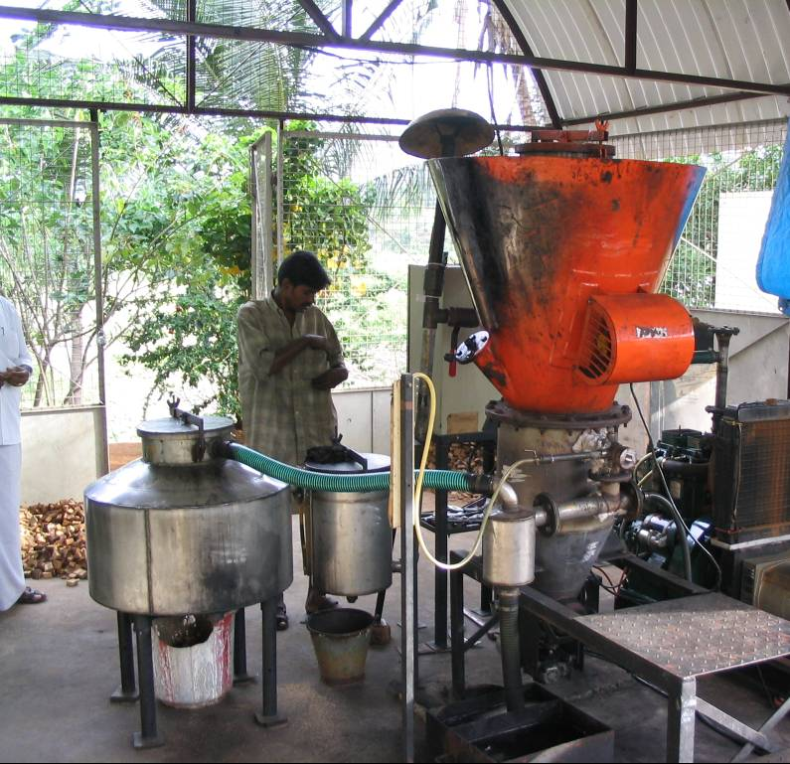
Panchayat is a general term of village cooperatives in India. Odanthurai Panchayat installed a 9kW biomass gasifier power generation system to substitute the grid electricity usage for pumping of drinking water supply system (Figure 3). The biomass gasifier system saves about 70% of pumping cost compare to using grid electricity (Table 2). This panchayat also has other renewable energy projects such as solar street lighting and biogas using human and domestic animal excrement. The biogas system is connected to each house for cooking purpose. People do not use firewood. Panchayat is purchasing waste wood from a sawmill in the village at very low price of Rs. 0.3/kg ($6.7/t) for the fuel of the gaisier. No demand of waste wood for cooking purpose might contribute the very low price. Total energy planning rather than just electrification can improve the efficiency. The grid electricity tariff is Rs. 4.5/kWh ($0.10) and not expensive but gasifier installation saves large amount of cost of the water supply system.
Figure 3. The 9 kW gasifier system installed for Odanthurai Panchayat water supply system in Tamil Nadu State.

Summary of Odanthurai Panchayat Gasifier System
Plant capacity : 9 kW
Cost of installation : Total - Rs. 310,000 ($6,700)
MNES subsidies – Rs. 135,000
Panchayat contribution – Rs. 175,000
No. of consumers : 3497 people
Operation hours : 12 hours
Tariff structure : Rs. 30 ($0.67) / HH / month
Fuel efficiency : 1.5 kg of wood / kWh
Cost of fuel : Rs. 0.30 / kg ($6.7/t) dry wood

Nellithurai Panchayat
This is almost same installation with Odanthurai Panchayat. The difference is that Nellithurai Pancheyat operate the gasifier during the night to supply power for 90 street lights to maximize the plant capacity factor. There were street light connected to grid electricity but the pnachayat stopped using them and installed new street lights connected to the gasifier system. Electricity Bureau (EB) does not allow small IPP (< 1 MW) to supply electricity in the area connected to grid therefore the idea of street lighting is adopted. The cost for water pumping and street lights used to be about Rs. 20,000 ($450) per month but the cost reduced to Rs. 6,000 ($130) per month after installation of biomass gasifier system.

Summary of Nellithurai Panchayat Gasifier System
Plant capacity : 9 kW
Operation hours : 9:00 am – 6:00 pm / Pump x 3
6:00 pm – 2:30 am / Pump x 1 and street lights (36 W) x 90
Tariff structure : Rs. 30 ($0.67) / HH / month
Fuel efficiency : 1.5 kg of wood / kWh
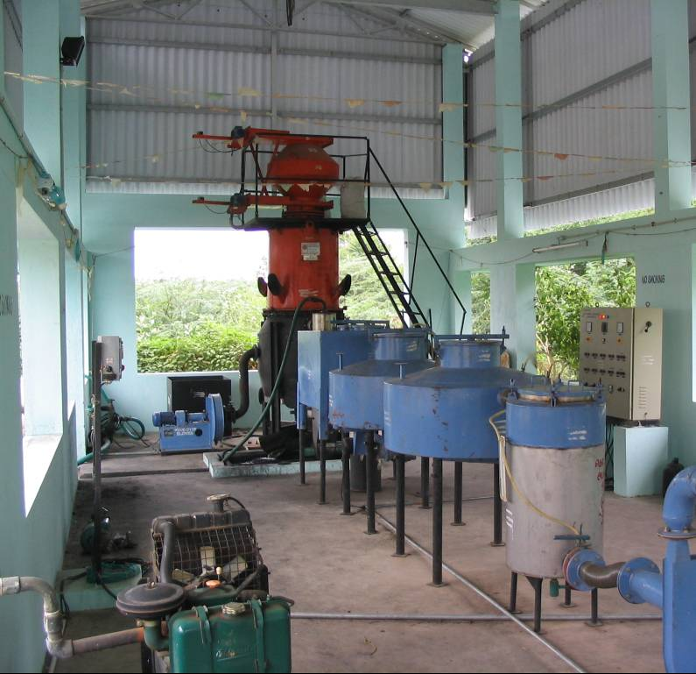
Cost of fuel : Rs. 800 ($17.8) / t dry wood
Figure 4. The 40 kW gasifier installed at Pallipalayam Panchayat, Tamil Nadu State.

Pallipalayam Panchayat
They installed 40 kW gasifier systems for water supply system. The system is almost same as other two installations shown above except the plant capacity. They purchase fuel wood from village people. The species are mainly wild grown Juliflora. No planting activities have been conducted.

Summary of Pallipalayam Panchayat Gasifier System
Plant capacity : 40 kW
Operation hours : 10 hours / day
Year of installation : 2004
No. of consumers : 1,000 HH
Tariff structure : Rs. 40 ($0.90) / HH / month
Fuel efficiency : 1.5 kg of wood / kWh
Cost of fuel : Rs. 1000 ($22.2) / t dry wood
Hitofumi Abe
Ecosystem Research Group, University of Western Australia JICA study team for 'The Master Plan Study on Rural Electrification by Renewable Energy in The Kingdom of Cambodia'

Ecosystem Research Group
School of Plant Biology (M090)
Faculty of Natural and Agricultural Science, The University of Western Australia
35 Stiriling Highway, Crawley,
WA 6009, Australia
FAX +61 8 6488 7925
Phone +61 8 6488 4257
E-mail abejin@plants.uwa.edu.au
http://www.plants.uwa.edu.au/home/research/research_centres/ergo/

For more information on the Tamil Nadu power station go to:
http://mnes.nic.in/annualreport/2004-2005_English/ch7_pg4.htm

