FACT SHEET
Flex-MicroturbineTM Arizona Demonstration Project

PARTICIPANTS
This project is funded by the State of Arizona through the Department of Energy’s NICE³ program, and matched with support from the National Rural Electric Cooperative Association. The Energy & Environmental Research Center (EERC) at the University of North Dakota (UND) has been subcontracted by Flex-Energy, the developer of the Capstone Flex-MicroturbineTM to provide a trailer mounted biomass gasification system. The demonstration project will be located in Cameron, AZ on the Navajo Reservation at a log home manufacturing site. The site is owned by Indigenous Community Ventures (ICV) who utilize typically low value round wood to manufacture their product.

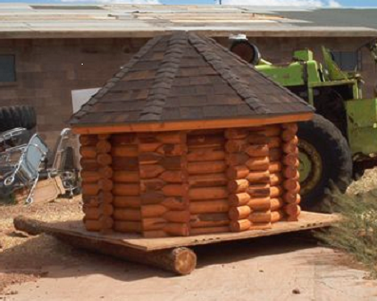

(Product of Indigenous Community Ventures & Example of a 30 kW Microturbine)

GOAL
Demonstrate a mobile power plant in use at a commercial enterprise converting biomass residue to electric power via a gasification Flex-MicroturbineTM system.

SCOPE
The EERC has been contracted by Flex-Energy to provide a commercially viable portable biomass gasification system capable of producing 90 kW of electric power. The EERC is primarily responsible for the following.

- Procurement and design of a portable biomass gasification system.
- Integration with 3 Flex-Microturbines supplied by Flex-Energy through Capstone Turbine Corporation.
- Operation and documentation of the system at a facility in Arizona.

PROGRESS
As of 11/25/03, the EERC has constructed the gasification system and procured all major equipment. Flex-Microturbines are under construction and a prototype has acquired 1500 hours of run time on bottled low Btu gas. Shakedown testing of the entire system is expected in March 2004. A 3-month demonstration is planned at ICV.

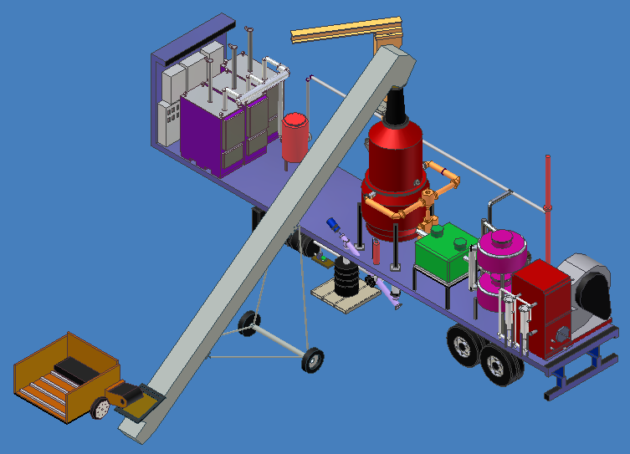

(150 kW Biomass Flex-MicroturbineTM Power Plant)

CONCLUSION
This project will establish an economic base line for the technology and further commercialization. Small biomass power technologies provide a better fit to available resources than large power plants, and gasification provides an economic alternative to steam based power production for small scale facilities.

BENEFITS
- A portable power plant provides the opportunity to mitigate forest fires by converting forest residue that would typically be left unused.
- Utilization of waste residue as a renewable fuel saves landfill space, and costs.
- Emissions from decay are reduced and a zero-net gain of CO2 is obtained. Emissions relative to coal fired power generation are offset.
- Options for self-generation of power from biomass provides stimulus to rural economies.
- Increased energy security

